

**Coordinators Training Manual for Regularly Scheduled Series (RSS)**

**September 2022**

*All rights reserved © 2017, 2020, 2021, 2022*

# Table of Contents

Table of Contents 2

RSS Dashboard Introduction 3

RSS Icons and Status Definitions 9

Using the RSS Dashboard 11

SMS Texting 13

Credit Manager 14

Adding Credit for a User 16

Editing a User’s Credit Record 17

Deleting a User’s Credit Record 18

Verifying Credits for a User 19

# RSS Dashboard Introduction

CloudCME® offers the RSS Dashboard to users who want to easily manage RSS child activities. In the RSS Dashboard, users can view the child status, activity details, presentations and COI status, target audience, comments, and approval status. Users can also edit the activity, manage, and email Planners, Faculty, and Owners/Coordinators, upload and download presentations, override approval and generate flyers.

**IMPORTANT NOTE:** An Administrator must assign RSS Coordinators permission to use the RSS Dashboard via **Administration > User Screen Access**.

**NOTE:** If the RSS parent activity is a Case Conference (i.e. - tumor boards, M & M, etc.), and the “**Automatically Approve Case Conferences**” checkbox is checked in **Administration > Preferences > Miscellaneous**, the RSS parent and any child activities generated from the parent, will be automatically approved. Please see the Setup[1] article for additional information.

First, log into CloudCME® by clicking **Sign in with your Organization ID**, entering your email, password and clicking the **Login** button.

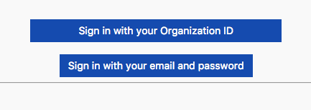

At the bottom of the screen, next to the drop-down box, click the **Administration** link.



Then, from the main menu, go to **Activities > RSS Dashboard**.

**NOTE**: This screen may vary depending on the user screen access that has been given.

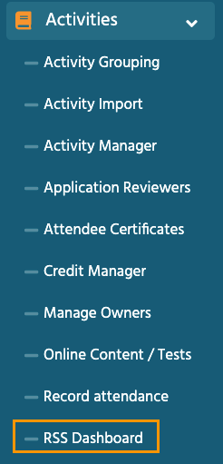

The **RSS Dashboard** screen will display.

The RSS Dashboard provides a minimized view to easily manage RSS activities. Coordinators will see all activities that they have been assigned as Coordinator/Owner **except** those that are **Approved** (unless **“Approved”** is selected in the **Status** search).

There are a variety of ways to search the RSS Dashboard. Users can search by the activity name, **Date Range**, **Status, Owner, Administrator, Location, Department, Planner, Faculty** or **Specialty**. Click **Search** to display results in the Dashboard.

**RSS Dashboard Columns**

The data table contains several columns to assist the Coordinator in managing the RSS activity planning process.

**NOTE:** Peer Review no longer triggers child event status changes. Status changes are now driven by the COI Mitigation Manager screen.

The following columns are included in the RSS Dashboard:

1. **Child Status** - As the RSS child activity goes through the approval process, this column will continuously update the status to **Incomplete**, **Pending**, **Approved**, **Rejected** or I**n Review**.



**In Review** - This status displays if faculty have been added with a completed disclosure and at least one financial relationship has been declared, triggering a COI Mitigation process needed. If one faculty member is rejected, and other faculty have been approved, the **Child Status** will remain **In Review**.

A **Review Disclosures** indicator will display in the **Status** column if a user has submitted a new Disclosure prior to the activity starting. There may be a new potential COl relationship that needs to be reviewed. Once the COI status has been addressed, the RSS status icon will update to the proper status and the indicator will be cleared.



**Faculty Added After Approval** - This indicator will appear in the **Status** column to notify Administrators that faculty members have been added to an activity after it has been approved. The status will automatically revert back to IN REVIEW.

1. **Details** - This column will display the **Series Name**, the date and time of the child activity, **Location**, **Department**, **Parent ID** and **Child ID**.

**3. Topic** - This column displays the name of the RSS child activity as well as the option to edit or create a flyer, view recurrence settings, and delete the activity.

1. **QR** - Single Scan QR is used for recording attendance by users logged in to the CloudCME® mobile app.

**5. Planners & COI Status** - This column displays the Planners associated with the child activity, **Disclosure** and **Disclosure Submitted** date, and the current COI status. If more than 3 Planners are assigned to the child activity, there will be a "**View All**" link that when clicked, will expand to show all assigned Planners or roll up the listing view.

**NOTE:** If you do not see the Planners & COI Status column, then your organization opted not to use it.

* Clicking the **Manage Planners** button will display a pop-up screen that allows RSS Coordinators to view, add or remove Planners, add or change Planners roles, and export planning committee member information.

* To add a Planner to the activity, type and select the planning committee member’s name in the drop-down box. Click the **Add Planner** button. The new member will be added to the activity and the planning committee member’s information will display in the Planners table.

**6. Faculty** - This column displays Faculty assigned to the RSS child activity. The Disclosure status will display beneath each faculty name along with their Disclosure submission date. If more than 3 faculty members are assigned to the child activity, there will be a "**View All**" link that when clicked, will expand to show all assigned Faculty, or roll up the listing view.

* Clicking the **Manage Faculty** button will display a pop-up screen that allows RSS Coordinators to email, view, add or remove Faculty, request disclosures and file uploads, and export faculty member information.
* To add a faculty member to the activity, type and select the member’s name in the drop-down box. Click the **Add Faculty** button. The new faculty member will be added to the activity and the member’s information will display in the **Manage Faculty** table.

* Click the faculty member’s name to request Disclosures, presentation files and other optional information, edit a member’s profile, and view uploaded files and past courses.

**7. Presentation & COI Status** - This column displays a faculty members' status, COI status, as well as icons to **Upload**, **Download** and **Remove** a faculty presentation. To upload a presentation, click the **Upload** icon, complete the Attestation, and select the file that will be uploaded. Once a file has been uploaded, the download and delete icons will display.

**8. Target Audience** - This column displays the **Specialties** and **Professions** that were selected during the parent activity setup. These can be revised on the **RSS Activity Editor** when the **Pencil** icon is selected.

**9. Owners/Coordinators** - This column displays the child activity Owners' and/or Coordinators' names as well as the option to send emails.

# ****RSS Icons and Status Definitions****

The columns in the RSS Dashboard contain several icons:

The following icons (1-4) can be found in the **Topic** column:

Pencil** - This icon opens the **RSS Activity Editor**. Here, a user can edit the child activity information.

**2.** **RSS Flyer** - The system will generate an RSS flyer for distribution. Faculty must be assigned to the activity before a flyer can be generated. The flyer template can also be customized for a unique RSS child or parent activity. The template can be applied to all child activities of the parent.

* To associate the revised flyer to the RSS parent for use per each child activity of the parent, click the **Upload Flyer** button, select the revised flyer from your desktop, and check the **Use flyer/template for Parent?** checkbox.

**NOTE**: The RSS flyer will be saved in the **Documents** tab in **Activity Manager** for the RSS activity.

**3.  Calendar** - Click this icon to view and edit scheduled RSS child activities.

**Trash** - Click this icon to deactivate/delete an RSS child activity. A pop-up window will display to confirmation deletion.

The following icons (1-8) can be found in the **Presentations & COI Status** column:

**1.  Incomplete** - This status represents Faculty where there is no disclosure on file, or their disclosure on file has expired. RSS Coordinators/Owners will see **Incomplete** by default until Faculty are assigned and disclosures have been completed.

**Pending** - This status represents Faculty whose disclosure and presentation are currently undergoing the COI Mitigation process. The system will send an email to the Administrator and Owner, containing all RSS child activities in which the activity status has been changed to **Pending**.

Disclosure Updated**- This icon will display if a user has submitted a new disclosure prior to the activity starting. There may be a new COI that needs to be reviewed. Once the COI status has been addressed, this icon will update.

**Approved** - This represents Faculty who have completed a disclosure, no financial relationships have been declared or, if identified, COI mitigation has been satisfactorily completed. The **Approved** status will also display if an Administrator or Activity Administrator conducts an Approval Override or if in **Administration > Preferences > COI Resolution** the "**Automatically Approve COI When Users Have Nothing to Disclose**" checkbox is checked.

**Rejected** - This represents Faculty who have completed a disclosure, at least one financial relationship has been declared, and the conflict is deemed immitigable. The child activity status is then updated to **Rejected**. The Coordinator will remove this faculty member, select a **new** faculty member, and begin the process again.

**Upload** - Upload a presentation file for the faculty member. Once a presentation has been uploaded, the download and delete icons will display.

**7.**  **Download** - Download a faculty member's presentation file.

**8.  Delete** - Delete a faculty member's presentation file.

The following icons (1,2) can be found in the **Faculty** and **Planner** columns:

**1.****Email:** Draft and send an email to the selected Faculty Member/Planner.

**2.Remove:**Remove a Faculty Member/Planner from the RSS child activity.

The following button can be found in the **Owners/Coordinators** column:

**Draft and send an email to Owners/Coordinators.

# Using the RSS Dashboard

Click the calendar icon (****) in the **Topic** column to display a pop-up window that will show a calendar with the reoccurrence dates of the child activities. To change the date of a child activity, users can drag and drop the child activity to a new day.

To edit a child activity, double-click on the activity in the calendar. A pop-up window will display. The radio button will default to **Edit only this occurrence**.

This option will only edit the child activity that was selected. To edit the entire series of child activities, select the **Edit the series** radio button. Click **OK**.

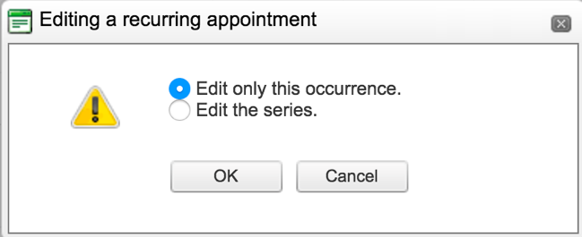

To edit the title of the child activity, type the new title into the textbox that will display. To revise the date or time the activity will occur, click the **Options** button.

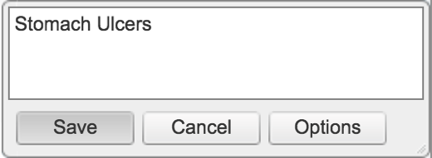

A new window will display. Here, users can create a child activity by filling in the text box, selecting the date and time the child activity will occur, and whether the activity have a recurrence.

Click the **Pencil** icon from the RSS Dashboard activity with the updated title. This icon can be found in the **Topic** column. The **RSS Activity Editor** screen will display. Here, users can edit and/or add additional information and upload supporting documentation for the child activity.

**NOTE:** The child activity title will display on users’ transcripts.

When all information has been entered, click the **Save & Close** button.

To customize the RSS flyer, click the **RSS Flyer** icon () and then click the **Download Microsoft Word Version** link. The flyer will open as a Word document. Make the desired changes and click **Save**.

**NOTE:** A list of merge fields that can be used in the RSS Flyer can be found here: [Document Merge Fields](https://cloudcme.zendesk.com/hc/en-us/articles/360039937971-Document-Merge-Fields#h_7d5f42ea-2582-4580-be55-4489c9da87b1). [2]

To associate the revised flyer to the RSS parent for use per each child activity of the parent, click the **Upload Flyer** button, select the revised flyer from your desktop, and check the **Use flyer/templates for Parent?** checkbox. Then, click the **Save**button.

# SMS Texting

These instructions are intended only for users that have an active account in CloudCME®. Attendance can only be recorded {X minutes prior to the meeting, during the activity, or X minutes after the meeting}.

**Step 1:** First, users must pair their mobile phone to their account in CloudCME®. Text the email address associated with this account to, {Enter your organization’s local exchange number}. A message will be sent that looks like the one below, confirming that the phone number has been updated.

**NOTE:** This is a one-time operation.

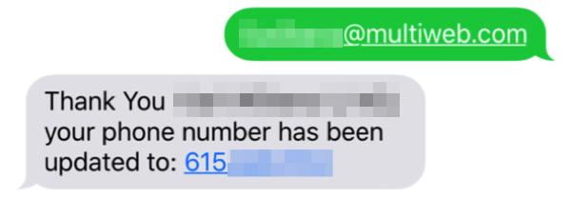

**Step 2:** To record attendance to an activity, text the activity ID or code that has been provided for the activity[3]. A message will be sent that verifies that activity attendance has been recorded.

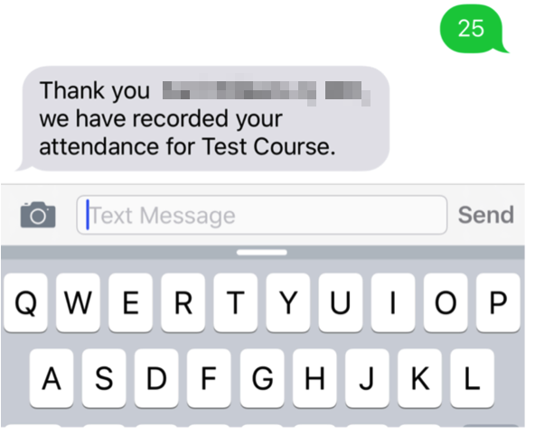

**NOTE:** Attendance can only be recorded once to an activity. If a user tries to record attendance an additional time, they will receive the following message:

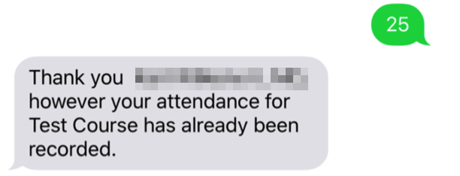

If a user attempts to use an activity code that does not exist, they will receive the following message:

# Credit Manager

While most RSS participants will text their attendance to be awarded continuing education credit, there may be instances where a participant is unable to text their attendance, or a credit record needs to be revised or deleted. When this occurs, we recommend using the **Credit Manager** screen.

To access **Credit Manager**, from the Main Menu, go to **Activities** > **Credit Manager**.

There are advantages to using the **Credit Manager** screen to add, revise or delete attendance and/or credits earned:

* Verification on who has earned continuing education credit upon completion of an activity can be done quickly as well as confirming the continuing education credit an individual user has earned.

There are several search options available:

* Enter a specific date range
* Enter a user’s name
* Enter the activity name
* Filter by specific Credit Type, Division, or Department
* Filter by MOC Credit Type Only

In most cases, the date range and activity search criteria will be used to locate the credit records. Enter the search criteria and click the **Search Credits** button.

# Adding Credit for a User

To add a user and their credit record for a specific RSS activity, select the date range. Type the activity name in the **Event** field and select it from the drop-down list.



**NOTE:** If adding a user’s credit record to an RSS child activity, make sure that the correct child activity has been selected by viewing the date and child ID number appended to the right of the RSS activity name.

When the screen refreshes, all users who have their attendance recorded to the activity will display in the data table.

To add additional users’ attendance and credits earned, click the +**Add** button.

After clicking the +**Add** button, additional fields will display.

In the **Lookup User** field, type the user’s last name and select from the drop-down list.

In the **Credit Type** field, select the appropriate continuing education credit the user should receive.

Select the **Attendance Date** using the calendar.

In the **Credit Hours** field, enter the number of credits that should be awarded to the user. This field defaults to 1, but a different credit amount may be entered.

Click the **Add Credit** button to record the user’s attendance and credit record.

If the user did not register for the activity, a message will display asking if you would like to add them via a complimentary registration. Once a user is registered for the activity, a message will display stating the user has been added to the registration list for the activity. Click **OK**.

When the screen refreshes, the user’s credit record will display in the data table. This confirms that the system has awarded the continuing education credit to the user.



# Editing a User’s Credit Record

A user’s credit record may need to be revised if:

* The credit amount was entered incorrectly.
* The user has an incorrect credit eligibility selected within their profile.
* The Attendance Date needs to be corrected.

Search for the records by entering the search criteria at the top of the **Credit Manager** screen as provided in the previous steps.

Locate the applicable record in the data table that needs to be revised.

**NOTE**: The credit type is a data point that will be revised in the user’s record in the screenshot below. To change the credit type for this user, change the user’s Credit Eligibility within their Profile in the **Attendee Portal** first.

Select the correct credit type from the drop-down list in the **Type** column.

To edit the user’s credit hours and credit date, enter the correct credit hours in the **Credit** column and select the correct date in the **Credit Date** column.

The changes will be highlighted in blue within the table. Click the **Update Highlighted Records** button to update the record.

# Deleting a User’s Credit Record

There may be instances when a user’s attendance and credit record needs to be deleted.

**NOTE:** This should be done with caution. When deleting a user’s attendance and credit record, this will also delete the record from the user’s transcript and their continuing education certificate. This information will be removed from their transcript and **Evaluations & Certificates** screens in the **Attendee Portal**.

To delete a user’s attendance record and continuing education credit from this screen, locate the user record in the data table. Click the **Delete** link in the far right column.

A confirmation message will display. Click **OK**.

The user’s record will be removed from the data table.

After this record has been deleted from the **Credit Manager** screen, the activity record will be removed from the user’s transcript.

aa

# Verifying Credits for a User

To verify attendance records and credits awarded to a specific user, use the **Date Range** and **User** fields to enter the search criteria and click the **Search Credits** button.



The screen will refresh, and all the attendance and credit records for the user will display.

Attendance and credits earned can be added for the specific user, as needed, following the steps above.

1. Note: Log in to the CloudCME® Administration area before clicking the Help article links.
2. Note: Log in to the CloudCME® Administration area before clicking the Help article links.
3. **You must text an SMS text message not an iMessage, if using iOS.**