

**Administrators Training Manual for Regularly Scheduled Series (RSS)**

September 2022

*All rights reserved © 2017, 2020, 2021, 2022*

# Table of Contents

Table of Contents 2

Introduction 3

Benefits of the RSS Dashboard 3

RSS Coordinators Setup 4

Create RSS Coordinator (Owner) Accounts via Bulk Import 4

RSS Coordinator (Owner) User Screen Access via Templates 5

Entering a New RSS Activity (The Parent) 9

Case Conferences 11

Auto-Generating RSS Child Activities (Sessions or Topics) 13

RSS Dashboard 14

RSS Dashboard Icons and Status Definitions 19

COI Mitigation Process 21

Summary 21

## Introduction

CloudCME® Administrators and Activity Administrators can auto-generate and approve RSS child activities as well as add comments to RSS child activities.

Coordinators/Owners will add and manage information within the RSS Dashboard, such as the Topic title, Faculty, Planners, presentations, and emails.

Regularly Scheduled Series management has five steps.

1. Create the overall RSS activity, typically via a submitted application. This is referred to as the Parent activity for the series.

1. Set up recurrence for the RSS child activities or sessions.

1. Generate RSS child activities. Children will inherit general information such as the Title, Description, etc. from the RSS Parent.

1. Assign an RSS Coordinator as an activity Owner. Ownership ensures that the RSS Coordinator works only with activities that they have been assigned as an Owner.

1. After RSS child activities are complete, approve the child activities.

## Benefits of the RSS Dashboard

* Activity information, emailing, and activity approval is easily accessible and conveniently located on the RSS Dashboard screen.
* Users are able to verify that upcoming RSS activities have any required presentations and/or documentation.
* Faculty added to the RSS activity can be auto-assigned a disclosure without navigating to Faculty Management.
* Flyers can be generated for the activity and exported to PDF/Word.
* Emails can be sent easily to Planners, Faculty, and Owners/Coordinators.
* Up to 20 objectives may be entered for each target audience.
* There are no restrictions for approval override.

## RSS Coordinators Setup

### Create RSS Coordinator (Owner) Accounts via Bulk Import

If the RSS Coordinators do not have CloudCME® accounts, accounts will need to be created for them.

**Step 1:** First, create an import file that contains all the RSS Coordinators’

information. In an Excel spreadsheet, create the column names based on the CloudCME® supported columns for Membership import.

Below are the required columns for import:

* **EMAIL –** the email address must be text and not a hyperlink.
* **CECreditCategoryID –** use the numerical value that corresponds to each user's credit eligibility which can be found in **Administration > Credit Types**. RSS Coordinators will have a CECreditCategoryID of 3 if they are not a licensed healthcare professional.
* **FIRSTNAME –** enter the first name. Formulas cannot be used.
* **LASTNAME –** enter the last name. Formulas cannot be used.
* **DEGREE -** use the numerical value that corresponds to the user's degree which can be found under **Administration > Credit Types**. This should be a numeric value.

All other columns are optional and can be found in the [Import Members](https://cloudcme.zendesk.com/hc/en-us/articles/206578645-Import-Members) Help Article.

**Step 2:** Once the import file is ready, go to **Membership > Import Members**.

Create a role for all RSS Coordinators. The selected role will be assigned to all users in the import file. The role assigned will display in reports such as the Membership report and will allow an Administrator to filter report data by a selected role, as well as allowing the option to send emails to all Coordinators with the same role.

**Step 3:** Next, in the **Select File:** field, click the **Select** button and locate the RSS Coordinator import file. Click the **Upload File & Import Users** button.

The system will validate the import file and the following message will display the import results. Click the **OK** button.

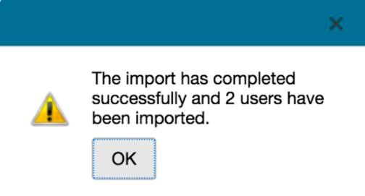

**NOTE**: Another option would be to set up an account for each RSS Coordinator by going to **Membership > Add Member**.

### RSS Coordinator (Owner) User Screen Access via Templates

After creating the RSS Coordinators’ CloudCME® accounts, access may need to be limited in the administrative area of CloudCME®.

To do this, create a User Screen Access template when providing screen access to RSS Coordinators. Creating a template requires a one-time action to select specific functionality sections and/or individual screen access.

Once a template has been created, bulk import all RSS Coordinators in one import file and assign the User Screen Access Template to those users. This is useful when multiple users should have the same access to sections or screens in the system administrative area.

**Step 1:** To begin, go to **Administration > User Screen Access > Update Templates** tab.

Check all the sections and individual screens that users with this role will have access to. Click the expand arrow beside the heading to access the individual screens.

**CloudCME® recommends creating an RSS Coordinators access template with the following screen access:**

Membership

* Add Member

Reports

* Credits
* Evaluations
* Disclosures
* RSS Attendance History
* Test Results
* Transcripts

Activities

* Credit Manager
* RSS Dashboard

**NOTE:** Limiting RSS Coordinators’ screen access to these sections will provide them with the screens needed for their job responsibilities, while reducing risk to prevent activity records and accreditation information from being erroneously deleted or changed.

**Step 2:** Once the screen selections are checked, click the **Create New Access Template** button.

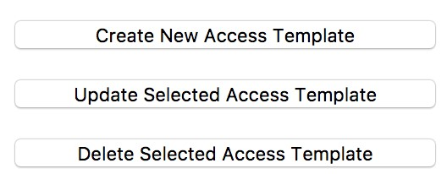

A window will display. Enter the name of the template and click the **OK** button.

The template name will be added to the list of templates and can be applied to users.

**Step 3:** Next, create the Excel import file. The file must contain the following column names and appear in this order:

* USERID
* EMAIL
* FIRSTNAME
* LASTNAME

**Step 4:** Go to the **Import User Screen Access** tab.

In the **Select File:** field, click the **Select** button.

Locate the import file and click the **Upload** **File** button.

**NOTE**: The column names in the Excel spreadsheet must match the column names. The names must be an exact match with no extra spaces or characters. The file will not validate if the column names do not match. The **USERID** field is **required**. The upload may take several minutes to complete.

When the file is validated, the following message will display. Click **OK**.

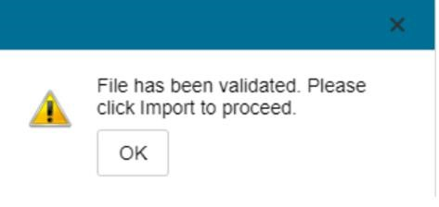

**Step 5:** Once the file is validated and uploaded, select the template name on the right and select the **Import Selected Access** button.

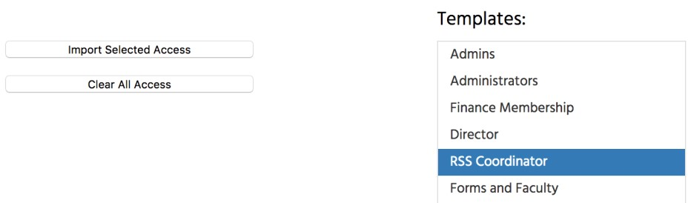

The system will assign users the selected access template, and the following message will display. Click the **OK** button.

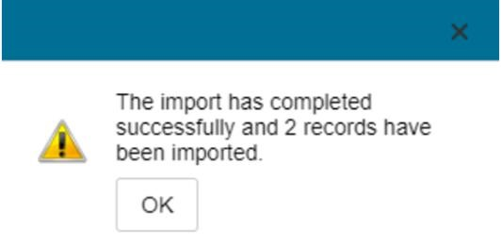

## Entering a New RSS Activity (The Parent)

If the activity is created from the application, the RSS Parent activity will automatically display in **Activity Manager**, after the application is approved. RSS parent activities can also be created manually in **Activity Manager**.

The steps below outline this process:

**Step 1:** First, log in to CloudCME® and click the **Administration** link.

From the Administration Dashboard, go to **Activities > Activity Manager**.

**Step 2:** Click the **+Add** button to enter a new activity.



A new screen will display. From the **Type** drop-down list, select **Directly Provided - Regularly Scheduled Series** or **Jointly Provided - Regularly Scheduled Series**. Enter the required information on the **Setup** tab and click **Update**.

**NOTE:** If you do not click **Update**, the system will not save the selections, and this process will have to be completed again.

### Case Conferences

If the RSS parent activity is a Case Conference activity type (i.e. - tumor boards, M & M, etc.), and the “**Automatically Approve Case Conferences**” checkbox is checked in **Administration > Preferences > Miscellaneous**, the RSS parent and any child activities generated from the parent, will be automatically approved. Please see the [Creating a Regularly Scheduled Series](https://cloudcme.zendesk.com/hc/en-us/articles/206577935-Creating-a-Regularly-Scheduled-Series)article for additional information.

Next, go to the **Activity Roles > Owners** tab and assign the Activity Coordinators to the Activity Owner role. Owners will see only those activities that have been assigned to them when performing an activity search throughout the system.

**NOTE**: Assigning ownership to an RSS parent activity will give access to all child activities. Ownership for specific child activities can be modified later.

Select the checkbox next to the Activity Owner role, enter the user’s last name, and select the user from the drop-down list. Then, click the **Add** button.

**NOTE:** This training manual does not address how to enter **Specialties**, **Objectives**, and other details in setting up an RSS activity. The remainder of this document will focus on generating child activities that can be managed and completed by the RSS Coordinator (Owner).

The following fields and information will carry down to all RSS child activities.

**NOTE:** The information must be entered before clicking the **Auto-Generate Child Activities** button.

* Activity Format
* ACCME Activity ID
* Accreditation Selections
* Allow Texting Minutes After
* Allow Texting Minutes Prior
* ANCC Activity ID
* Attendee Max #
* Credit Hours
* Credit Types
* City
* Competencies
* Country
* Department
* Description
* Evaluation (if set up on Evaluation tab)
* Event Active
* Faculty (if checkbox is checked on the Date & Time tab)
* Faculty Tasks (if checkbox is checked on the Date & Time tab)

* Is this a Case Conference?
* Joint Accreditation Activity ID
* Location
* Mitigation of Financial Relationships Statement (if completed on the Marketing tab for the RSS Parent)
* MOC
* Objectives (if checkbox is checked on the Date & Time tab)
* Parent Event Name
* ParentEventID – ChildEvent ID
* Pharmacist UAN
* Registration Form Active
* Show in AP
* Specialties
* State
* Sub-Category
* Technician UAN
* Timezone
* Type

The following information can be carried down to child activities afterclicking the **Auto-Generate Child Activities** button, if needed.

* Activity credits, (only the credits designated to the RSS Parent general session) if the **Apply credits to all children?** checkbox is checked.
* All checkbox selections on the **Publishing** tab when clicking the **Apply Settings to Children** button.
* Default Forms, assigned on the **Faculty** tab, when clicking the **Assign to Children** button.
* Evaluation, (if set up on the RSS Parent) when clicking the **Assign Evaluation Form to Children**.
* Faculty, if the **Add Faculty to Children checkbox** is checked.
* Faculty Tasks, if the **Assign to Children** button is clicked.
* Marketing information, if the **Apply to Children** button is clicked to the right of each field.

## Auto-Generating RSS Child Activities (Sessions or Topics)

Select the **Date/Time** tab. When creating RSS activities, the **Start** and **End Date** for the activity *must* be the first day of the activity. Enter the date and correct time in *both* fields.

Enter the appropriate **TimeZone**, **Allow Texting Minutes Prior** and **Allow Texting Minutes After** and click the **Update** button.

Next, check the **Recurrence** box, set the frequency of the RSS activity, and click the **Update** button.

When the screen refreshes, an **Auto-Generate Child Activities** button will display as well as “**Children Inherit Objectives**”, “**Children Inherit Planners**”, “**Children Inherit Faculty**”, “**Children Inherit Faculty Tasks**” checkboxes. If an evaluation has not been set for the Parent activity, child activities cannot inherit an evaluation so the corresponding checkbox would remain unchecked in this case.

If any of these checkboxes are selected in the RSS parent, the information will carry down to the RSS child upon auto-generating child activities.

To create child activities, click the **Auto-Generate Child Activities** button. The system will create the RSS child activities per the frequency selected. A message will display indicating the number of RSS children created for the activity. The child activities will inherit the parent activity name and additional details. The RSS Coordinator (Owners) can update this information in the RSS Dashboard.

Click the **Update** button to save the selections.

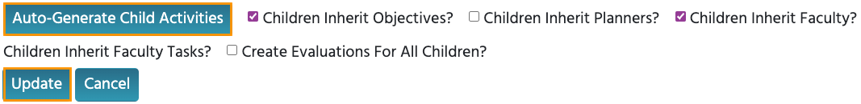

**NOTE:** If the **Update** button is not clicked, the process on this screen will need to be completed again.

## RSS Dashboard

RSS Coordinators (Owners) will work on their assigned child activities in the RSS Dashboard and Administrators will review and approve the activities in the RSS Dashboard. To access the RSS Dashboard, from the main menu, go to **Activities > RSS Dashboard**.

For Administrators, the default status for RSS activities will be *Incomplete*. (Please see the RSS Dashboard Icons and Status Definitions section below for status definitions).[1] Search for an RSS child activity by typing the activity name in the search box. Also, the following filters can be used to narrow the search results for activities: **Date Range, Status, Owner, Administrator, Location, Department, Planner, Faculty**or**Specialty.**

Click the**Search** button to display results.

As the RSS child activity goes through the approval process, this column will continuously update the **Child Status** column to **Incomplete**, **Pending**, **Approved**, **Rejected,** or I**n Review**.

**NOTE:** Peer review no longer triggers child activity status changes. Status changes are now driven by the COI Mitigation process.



* **In Review** - This status displays if faculty have been added with a completed disclosure and at least one financial relationship has been declared, triggering the COI Mitigation process. If one faculty member is rejected, and other faculty have been approved, the **Child Status** will remain **In Review**.
* ** Review Disclosures** - This indicator will display in the **Status** column if a user has submitted a new Disclosure prior to the activity starting. There may be new COl information that needs to be reviewed. Once the COI status has been addressed, the RSS status icon will update to the proper status and the indicator will be cleared. An orange **Disclosure Updated** icon will display within the **Presentations & COI Status** column as well. Once the COI status has been addressed, this icon will update.
* Diagram

  Description automatically generated **Faculty Added After Approval** - This will appear in the **Status** column to notify Administrators that faculty members have been added to an activity after it has been approved. The status will automatically revert back to IN REVIEW.

) in the **Topic** column. Topic titles will display in users’ transcripts after attendance is recorded. For this reason, the child activity title should be reviewed.

After clicking the **Pencil** icon, the RSS Activity Editor screen will display. Here, Coordinators will have the option to edit the RSS child activity name. Many other editing options are available as well. Click the **Save** **& Close** button at the bottom of the screen to save changes and return to the main RSS Dashboard screen.

Emails can be sent to the RSS Coordinator (Owner) by clicking the **Send** button in the **Owners/Coordinators** column.

A screen will display. Here, an email can be composed and sent.

**Planners & COI Status** - This column displays the Planners associated with the child activity, **Disclosure** and **Disclosure Submitted** date, and the current COI status. If more than 3 Planners are assigned to the child activity, there will be a "**View All**" link that when clicked, will expand to show all assigned Planners or roll up the listing view.

* Clicking the **Manage Planners** button will display a pop-up screen that allows RSS Coordinators to view, add or remove Planners, add or change Planners roles, and export planning committee member information.

* To add a Planner to the activity, type and select the planning committee member’s name in the drop-down box. Click the **Add Planner** button. The new member will be added to the activity and the planning committee member’s information will display in the Planners table.

**NOTE:** The **Planners and COI Status** column will be hidden by default. This column can be displayed by going to **Administration > Preferences > Miscellaneous** and checking the “**Allow Adding and Removing of Planners in RSS Dashboard**” checkbox.

**Faculty** - This column displays Faculty assigned to the RSS child activity. The Disclosure status will display beneath each faculty name along with their Disclosure submission date. If more than 3 faculty members are assigned to the child activity, there will be a "**View All**" link that when clicked, will expand to show all assigned Faculty, or roll up the listing view.

* Clicking the **Manage Faculty** button will display a pop-up screen that allows RSS Coordinators to email, view, add or remove Faculty, request disclosures and file uploads, and export faculty member information.

* To add a faculty member to the activity, type and select the member’s name in the drop-down box. Click the **Add Faculty** button. The new faculty member will be added to the activity and the member’s information will display in the **Manage Faculty** table.

A **Comments** column is available to Administrators and Activity Administrators. Comments added in this column will populate into the comments window within the **COI Mitigation Manager** screen.

The **Approval** column is used by only Administrators and Activity Administrators. Administrators and Activity Administrators can approve an RSS child activity as well as perform approval overrides by clicking the **Approve Child** button. Once approved, the button will then display as **Approved**.

**NOTE:** Only **Approved** activities can award SMS text message credits in the system. An unapproved RSS child activity will not award credits.

An Approval Override comment window will display. Enter the approval comment(s) and click the **Approve Child** button. The activity will then display as **Approved** in the RSS Dashboard.

### RSS Dashboard Icons and Status Definitions

The columns in the RSS Dashboard contain several icons. Below are definitions of each icon.

The following icons (1-4) can be found in the **Topic** column:

Pencil** - This icon opens the **RSS Activity Editor**. Here, a user can edit the child activity information.

**2.** **RSS Flyer** - The system will generate an RSS flyer for distribution. Faculty must be assigned to the activity before a flyer can be generated. The flyer template can also be customized for a unique RSS child or parent activity. The template can be applied to all child activities of the parent.

* To associate the revised flyer to the RSS parent for use per each child activity of the parent, click the **Upload Flyer** button, select the revised flyer from your desktop, and check the **Use flyer/template for Parent?** checkbox.

**NOTE**: The RSS flyer will be saved in the **Documents** tab in **Activity Manager** for the RSS activity.

**3.  Calendar** - Click this icon to view and edit scheduled RSS child activities.

**Trash** - Click this icon to deactivate/delete an RSS child activity. A pop-up window will display to confirmation deletion.

The following icons (1-8) can be found in the **Presentations & COI Status** column:

**1.  Incomplete** - This status represents Faculty where there is no disclosure on file, or their disclosure on file has expired. RSS Coordinators/Owners will see **Incomplete** by default until Faculty are assigned and disclosures have been completed.

**Pending** - This status represents Faculty whose disclosure and presentation are currently undergoing the COI Mitigation process. The system will send an email to the Administrator and Owner, containing all RSS child activities in which the activity status has been changed to **Pending**.

Disclosure Updated**- This icon will display if a user has submitted a new disclosure prior to the activity starting. There may be a new COI that needs to be reviewed. Once the COI status has been addressed, this icon will update.

**Approved** - This represents Faculty who have completed a disclosure, no financial relationships have been declared or, if identified, COI mitigation has been satisfactorily completed. The **Approved** status will also display if an Administrator or Activity Administrator conducts an Approval Override or if in **Administration > Preferences > COI Resolution** the "**Automatically Approve COI When Users Have Nothing to Disclose**" checkbox is checked.

**Rejected** - This represents Faculty who have completed a disclosure, at least one financial relationship has been declared, and the conflict is deemed immitigable. The child activity status is then updated to **Rejected**. The Coordinator will remove this faculty member, select a **new** faculty member, and begin the process again.

**Upload** - Upload a presentation file for the faculty member. Once a presentation has been uploaded, the download and delete icons will display.

**7.**  **Download** - Download a faculty member's presentation file.

**8.  Delete** - Delete a faculty member's presentation file.

The following icons (1,2) can be found in the **Faculty** and **Planner** columns:

**1.****Email:** Draft and send an email to the selected Faculty Member/Planner.

**2.****Remove:**Remove a Faculty Member/Planner from the RSS child activity.

### COI Mitigation Process

In **Forms**, the COI **Mitigation Management** form is triggered when a faculty member has declared at least one financial relationship, and the faculty member’s presentation has been uploaded for review. An email will be sent to the user that has been assigned the Peer Reviewer role for the activity. This form is automatically assigned to all activities.

For more information, visit our COI Mitigation Manager Help article.[2]

## Summary

The RSS Dashboard is designed to bring RSS child activities or sessions together into one screen, making it easy for RSS Coordinators (Owners) to focus on only the required items needed to meet full documentation of the activity.

The RSS Dashboard makes Administrators’ work easier, by pushing the details out to the RSS Coordinator to complete. Ideally, the Administrator or Activity Administrator reviews and approves completed activities.

1. You must be logged in to CloudCME® to access the Help articles.
2. You must be logged in to CloudCME® to access the Help articles.