
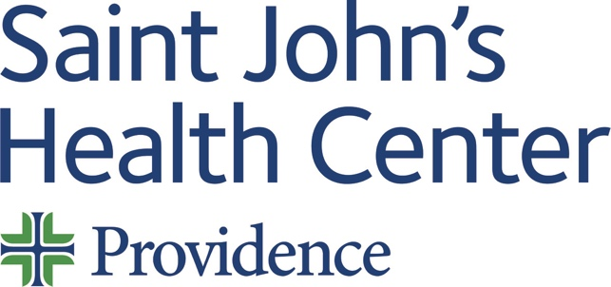

Monday 04 September 2023 – Through 31 December 2023
12:00 PM
“Cardiac Cath Conference”

Target Audience
Physician, Non-Physician, Physician Assistant, Nurse Practitioner, Registered Nurse
Learning Objectives
“At the conclusion of this activity, learners will be able to …”
      - Utilize case data presented to make recommendations for appropriate management.
      - Employ cardiology and cardiac surgery current guidelines when appropriate.
      - Consider patient age, gender, socioeconomics, co-morbidities when making patient care decisions.
Accreditation and Designation Statements
Saint John’s Health Center (SJHC) is accredited by the California Medical Association (CMA) to provide continuing medical education for physicians.

SJHC designates this live activity for a maximum of 1.00 AMA PRA Category 1 Credit™. Physicians should claim only credit commensurate with the extent of their participation in the activity.
Disclosure Information
Name of individual | Individual's role in activity | Name of Ineligible Company(s) / Nature of Relationship(s)
Judy Hyle, CHCP | CME Compliance Officer | Nothing to disclose - 03/10/2023
Peter Pelikan, MD | Course Director | Nothing to disclose - 10/28/2022

For questions or concerns email: MedicalStaffServices2@providence.org
This email does not accept incoming messages.

