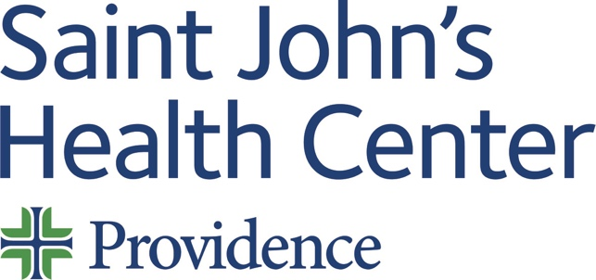

Date: Thursday 16 January 2025
Time: 08:00 AM

Target Audience: Allergy And Immunology, Anesthesiology, Colon And Rectal Surgery, Dermatology, Dental Surgery, Emergency Medicine, Family Medicine, Internal Medicine, Medical Genetics And Genomics, Neurological Surgery, Nuclear Medicine, Obstetrics And Gynecology, Ophthalmology, Orthopaedic Surgery, Otolaryngology-Head And Neck Surgery, Pathology, Pediatrics, Physical Medicine And Rehabilitation, Plastic Surgery, Preventive Medicine, Psychiatry And Neurology, Psychology, Radiology, Surgery, Thoracic Surgery, Urology

Topic: “2025 Skin Tumor Board”

Describe this activity
Text Code: 3367 | Multidisciplinary cutaneous oncology tumor board
Join Zoom Meeting
https://us06web.zoom.us/j/86219008694?pwd=QzZoZUR4YlF0NVlNcTZZNTIxTlBQQT09
Meeting ID: 862 1900 8694
Passcode: 377784
One tap mobile
+16694449171,,86219008694#,,,,*377784# US
+16699006833,,86219008694#,,,,*377784# US (San Jose)
Dial by your location
+1 669 444 9171 US
+1 669 900 6833 US (San Jose)
+1 346 248 7799 US (Houston)
+1 719 359 4580 US
+1 253 215 8782 US (Tacoma)
+1 564 217 2000 US
+1 646 931 3860 US
+1 689 278 1000 US
+1 929 205 6099 US (New York)
+1 301 715 8592 US (Washington DC)
+1 309 205 3325 US
+1 312 626 6799 US (Chicago)
+1 360 209 5623 US
+1 386 347 5053 US
+1 507 473 4847 US
Meeting ID: 862 1900 8694
Passcode: 377784
Find your local number: https://us06web.zoom.us/u/kdJmVRipwC

Learning Outcomes
1 Follow NCCN surgical, medical, radiologic treatment guidelines, and AJCC staging
CME Credit
Providence Saint John’s Health Center is accredited by the California Medical Association (CMA) to provide continuing medical education for physicians.

Providence Saint John’s Health Center designates this Live Activity for a maximum of 1.00 AMA PRA Category 1 Credit™. Physicians should claim only the credit commensurate with the extent of their participation in the activity.

Commercial and/or Exhibit Support
No commercial support has influenced the planning, implementation, or evaluation of the content of this activity.

Disclosure Information
Providence Saint John's Health Center Continuing Medical Education adheres to the ACCME’s Standards for Integrity and Independence in Accredited Continuing Education. Any individuals in a position to control the content of a CE activity, including faculty, planners, reviewers, or others are required to disclose all financial relationships with ineligible entities (commercial interests). All relevant financial relationships have been mitigated prior to the commencement of the activity.
Name of individual | Individual's role in activity | Nature of Relationship(s) / Name of Ineligible Company(s)
David M Cutler, MD | Planning Committee Member | Consulting Fee-Pfizer (Any division) (Relationship has ended) - 01/25/2024
Ronnie Abraham, MD | Co-Director | Nothing to disclose - 10/11/2024
Steven Kolker, MD | Co-Director
Judy Hyle, CHCP | CME Compliance Officer | Nothing to disclose - 11/07/2024

For questions or concerns email: MedicalStaffServices2@providence.org

