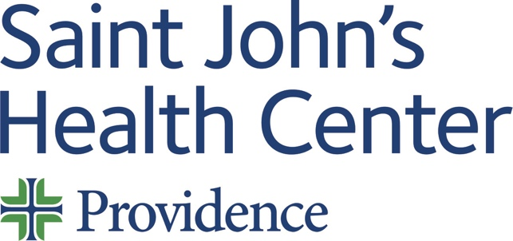

Date: Thursday 09 January 2025
Time: 07:30 AM

Target Audience: Allergy And Immunology, Anesthesiology, Colon And Rectal Surgery, Dermatology, Dental Surgery, Emergency Medicine, Family Medicine, Internal Medicine, Medical Genetics And Genomics, Neurological Surgery, Nuclear Medicine, Obstetrics And Gynecology, Ophthalmology, Orthopaedic Surgery, Otolaryngology-Head And Neck Surgery, Pathology, Pediatrics, Physical Medicine And Rehabilitation, Plastic Surgery, Preventive Medicine, Psychiatry And Neurology, Psychology, Radiology, Surgery, Thoracic Surgery, Urology, Urologic Oncology, Urology, Gynecologic Oncology, Obstetrics & Gynecology, Urology, Female Pelvic Medicine And Reconstructive Surgery, Pediatric Urology

Topic: “2025 Genitourinary Tumor Board”

Describe this activity
Text the code 3366 to the CloudCME phone number (844) 626-1442 to record your attendance during the meeting. | This GU tumor board is designed to review challenging and interesting cases. This CME activity is for Medical Staff Members and APP's at Providence Saint John's Health Center.
Join Zoom Meeting
https://us06web.zoom.us/j/88361168225?pwd=Zi81MTljbXBTTGROMk91bkdIZWdXUT09
Meeting ID: 883 6116 8225
Passcode: 897647

Learning Outcomes
1 Formulate a state of the art management plan for various stages of prostate cancer.
1 Design appropriate radiation therapy schedules for treatment of prostate cancer.
1 Utilize modern cancer genetics to improve patient care.
1 Follow NCCN guidelines and treatment pathways.
2 Prescribe the appropriate drugs used in the treatment of advanced bladder cancer.
3 Employ focal therapy options for treatment of localized kidney cancer.
5 Order appropriate imaging and interpret results of scans in GU oncology.
CME Credit
Providence Saint John’s Health Center is accredited by the California Medical Association (CMA) to provide continuing medical education for physicians.

Providence Saint John’s Health Center designates this Live Activity for a maximum of 1.50 AMA PRA Category 1 Credit™. Physicians should claim only the credit commensurate with the extent of their participation in the activity.

Commercial and/or Exhibit Support
No commercial support has influenced the planning, implementation, or evaluation of the content of this activity.

Disclosure Information
Providence Saint John's Health Center Continuing Medical Education adheres to the ACCME’s Standards for Integrity and Independence in Accredited Continuing Education. Any individuals in a position to control the content of a CE activity, including faculty, planners, reviewers, or others are required to disclose all financial relationships with ineligible entities (commercial interests). All relevant financial relationships have been mitigated prior to the commencement of the activity.
Name of individual | Individual's role in activity | Nature of Relationship(s) / Name of Ineligible Company(s)
David M Cutler, MD | Planning Committee Member | Consulting Fee-Pfizer (Any division) (Relationship has ended) - 01/25/2024
Przemyslaw Twardowski, MD | Course Director | Speakers Bureau-Astellas (Any division)|Consulting Fee-Novartis Corporation Pharmaceuticals|Speakers Bureau-AstraZeneca (Any division)|Speakers Bureau-Bristol-Myers Squibb Company|Speakers Bureau-Merck (Any division) - 09/03/2024
Judy Hyle, CHCP | CME Compliance Officer | Nothing to disclose - 11/07/2024

For questions or concerns email: MedicalStaffServices2@providence.org

