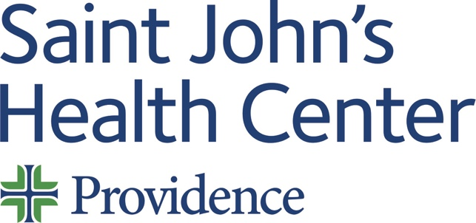

Date: Wednesday 01 January 2025
Time: 05:30 PM

Target Audience: Allergy And Immunology, Anesthesiology, Colon And Rectal Surgery, Dermatology, Dental Surgery, Emergency Medicine, Family Medicine, Internal Medicine, Medical Genetics And Genomics, Neurological Surgery, Nuclear Medicine, Obstetrics And Gynecology, Ophthalmology, Orthopaedic Surgery, Otolaryngology-Head And Neck Surgery, Pathology, Pediatrics, Physical Medicine And Rehabilitation, Plastic Surgery, Preventive Medicine, Psychiatry And Neurology, Psychology, Radiology, Surgery, Thoracic Surgery, Urology, Medical Oncology, Complex General Surgical Oncology

Topic: “2025 SJCI Grand Rounds”

Describe this activity
Code: 3345 | Saint Johns Cancer Institute Grand Rounds is a regularly scheduled 1 hour presentation series on topics pertaining to cancer including translational science, biostatistics, genetics, population studies and epidemiology, patient outcomes, and costs of care. The topics covered include solid and hematologic malignancies and are relevant for all healthcare workers.
Click here to join the Teams Meeting
Meeting ID: 214 152 602 035
Passcode: iYTgVv

Learning Outcomes
1 Analyze the most current data available and write the best treatment plan for that patient
2 Refer patients to ancillary services of nutrition, mental health, and palliative care when appropriate
3 Write a treatment plan that includes consideration of patients cultural and religious beliefs, age, ethnicity, socioeconomic status, and co-morbidities
4 Recommend patients to suitable clinical trials and research studies
CME Credit
Providence Saint John’s Health Center is accredited by the California Medical Association (CMA) to provide continuing medical education for physicians.

Providence Saint John’s Health Center designates this Live Activity for a maximum of 1.00 AMA PRA Category 1 Credit™. Physicians should claim only the credit commensurate with the extent of their participation in the activity.

Commercial and/or Exhibit Support
No commercial support has influenced the planning, implementation, or evaluation of the content of this activity.

Disclosure Information
Providence Saint John's Health Center Continuing Medical Education adheres to the ACCME’s Standards for Integrity and Independence in Accredited Continuing Education. Any individuals in a position to control the content of a CE activity, including faculty, planners, reviewers, or others are required to disclose all financial relationships with ineligible entities (commercial interests). All relevant financial relationships have been mitigated prior to the commencement of the activity.
Name of individual | Individual's role in activity | Nature of Relationship(s) / Name of Ineligible Company(s)
David M Cutler, MD | Planning Committee Member | Consulting Fee-Pfizer (Any division) (Relationship has ended) - 01/25/2024
Richard Essner, MD, physician and surgeon | Course Director | Advisor-Intramedical Imaging (Relationship has ended)|Speakers Bureau-Castle Biosciences - 03/14/2024
Judy Hyle, CHCP | CME Compliance Officer | Nothing to disclose - 11/07/2024

For questions or concerns email: MedicalStaffServices2@providence.org

