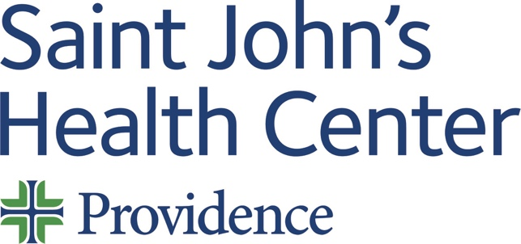

Date: Monday 06 January 2025
Time: 08:00 AM

Target Audience: Family Medicine, Internal Medicine, Medical Genetics And Genomics, Pathology, Plastic Surgery, Radiology, Surgery

Topic: “2025 Breast Cancer Tumor Board”

Describe this activity
Text code 3341 to the CloudCME phone number (844) 626-1442 to record your attendance during the meeting.
Breast Cancer Tumor Board meets weekly to discuss current breast cancer cases and facilitate treatment plans. Cases are presented for their history, pathology, radiology and treatment options. This is for Medical Staff Members and APP's at Providence Saint John's Health Center.
Join Zoom Meeting
https://us06web.zoom.us/j/84217791108?pwd=UTBKUXlWcVMwaWl0aG5ySHgrb3UzZz09
Meeting ID: 842 1779 1108
Passcode: 218173

Learning Outcomes
1 Collaborate and write a treatment plan based on NCCN guidelines.
CME Credit
Providence Saint John’s Health Center is accredited by the California Medical Association (CMA) to provide continuing medical education for physicians.

Providence Saint John’s Health Center designates this Live Activity for a maximum of 1.00 AMA PRA Category 1 Credit™. Physicians should claim only the credit commensurate with the extent of their participation in the activity.

Commercial and/or Exhibit Support
No commercial support has influenced the planning, implementation, or evaluation of the content of this activity.

Disclosure Information
Providence Saint John's Health Center Continuing Medical Education adheres to the ACCME’s Standards for Integrity and Independence in Accredited Continuing Education. Any individuals in a position to control the content of a CE activity, including faculty, planners, reviewers, or others are required to disclose all financial relationships with ineligible entities (commercial interests). All relevant financial relationships have been mitigated prior to the commencement of the activity.
Name of individual | Individual's role in activity | Nature of Relationship(s) / Name of Ineligible Company(s)
David M Cutler, MD | Planning Committee Member | Consulting Fee-Pfizer (Any division) (Relationship has ended) - 01/25/2024
Janie Grumley, MD, FACS | Co-Director | Nothing to disclose - 11/12/2024
Parvin F. Peddi, MD | Co-Director | Nothing to disclose - 02/16/2024
Judy Hyle, CHCP | CME Compliance Officer | Nothing to disclose - 11/07/2024

For questions or concerns email: MedicalStaffServices2@providence.org

