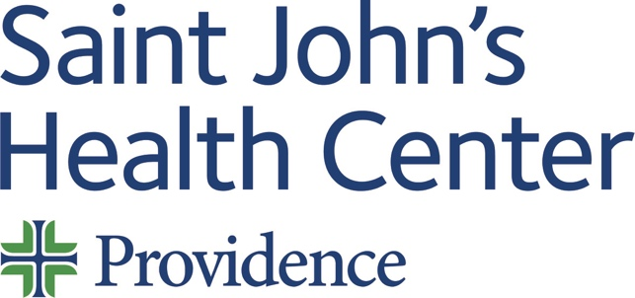

Live Activity:

Date: Thursday 11 January 2024
Time: 07:30 AM

Target Audience: Physician, Non-Physician, Physician Assistant, Nurse Practitioner, Registered Nurse

Topic: “2024 Genitourinary Tumor Board”

Describe this activity (CME Programs are designed in a multidisciplinary fashion hence curriculum may differ slightly from Expert Speaker*)
Code: 2220 | This is GU tumor board designed to review challenging and interesting cases
Join Zoom Meeting
https://us06web.zoom.us/j/88361168225?pwd=Zi81MTljbXBTTGROMk91bkdIZWdXUT09
Meeting ID: 883 6116 8225
Passcode: 897647
One tap mobile
+16699006833,,88361168225#,,,,*897647# US (San Jose)
+16694449171,,88361168225#,,,,*897647# US
Dial by your location
+1 669 900 6833 US (San Jose)
+1 669 444 9171 US
+1 719 359 4580 US
+1 253 205 0468 US
+1 253 215 8782 US (Tacoma)
+1 346 248 7799 US (Houston)
+1 301 715 8592 US (Washington DC)
+1 305 224 1968 US
+1 309 205 3325 US
+1 312 626 6799 US (Chicago)
+1 360 209 5623 US
+1 386 347 5053 US
+1 507 473 4847 US
+1 564 217 2000 US
+1 646 931 3860 US
+1 689 278 1000 US
+1 929 205 6099 US (New York)
Meeting ID: 883 6116 8225
Passcode: 897647
Find your local number: https://us06web.zoom.us/u/kcf4rovQ6C

How will this activity address cultural, linguistic & implicit bias gaps or disparities?
- Cultural & Linguistic Competencies addressed? Definition: “The ability and readiness of health care providers and organizations to humbly and respectfully demonstrate, effectively communicate, and tailor delivery of care to patients with diverse values, beliefs, identities and behaviors, in order to meet social, cultural and linguistic needs as they relate to patient health.”
- Implicit Bias addressed? Definition: “The attitudes, stereotypes and feelings, either positive or negative, that affect our understanding, actions and decisions without conscious knowledge or control. Implicit bias is a universal phenomenon. When negative, implicit bias often contributes to unequal treatment and disparities in diagnosis, treatment decisions, levels of care and health care outcomes of people based on race, ethnicity, gender identity, sexual orientation, age, disability and other characteristics.”
Professional Practice Gaps  Gaps are the difference between actual (what is) and ideal (what should be). List one or more problems in practice that this activity is attempting to address. | Educational Needs  Specify what the learner needs in order to close the gap. | Learning Objectives  What do you expect learners to be able to do as a result of this activity?  “At the conclusion of this activity, learners will be able to …”
1 Formulate a state of the art management plan for various stages of prostate cancer.
1 Design appropriate radiation therapy schedules for treatment of prostate cancer.
1 Utilize modern cancer genetics to improve patient care.
1 Follow NCCN guidelines and treatment pathways.
2 Prescribe the appropriate drugs used in the treatment of advanced bladder cancer.
3 Employ focal therapy options for treatment of localized kidney cancer.
5 Order appropriate imaging and interpret results of scans in GU oncology.
Sources:
Type of Needs:
The American Medical Association Physician’s Recognition Award and Continuing Medical Education Credit System
Saint John’s Health Center (SJHC) is accredited by the California Medical Association (CMA) to provide continuing medical education for physicians.

SJHC designates this live activity for a maximum of one point fifty (1.50) AMA PRA Category 1 Credit(s)™. Physicians should claim only credit commensurate with the extent of their participation in the activity.

This credit may also be applied to the CMA Certification in Continuing Medical Education.

Name of individual | Individual's role in activity | Nature of Relationship(s) / Name of Ineligible Company(s)
Przemyslaw Twardowski, MD | Course Director | Speakers Bureau-Astellas (Any division)|Speakers Bureau-Bayer (Any division)|Speakers Bureau-Janssen (Any division)|Speakers Bureau-AstraZeneca (Any division)|Speakers Bureau-Bristol-Myers Squibb Company|Speakers Bureau-Merck (Any division) - 04/25/2023

For questions or concerns email: MedicalStaffServices2@providence.org
This email does not accept incoming messages.

