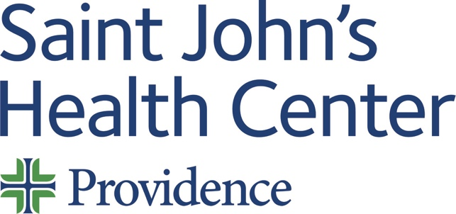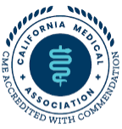

Live Activity:

Date: Monday 05 June 2023
Time: 08:00 AM

Topic: “Breast Cancer Tumor Board”

Describe this activity (CME Programs are designed in a multidisciplinary fashion hence curriculum may differ slightly from Expert Speaker*)
Code: 2116 | Breast Cancer Tumor Board meets weekly to discuss current breast cancer cases and facilitate treatment plans. Cases are presented for their history, pathology, radiology and treatment options.
Join Zoom Meeting
https://us06web.zoom.us/j/84217791108?pwd=UTBKUXlWcVMwaWl0aG5ySHgrb3UzZz09
Meeting ID: 842 1779 1108
Passcode: 218173
One tap mobile
+16694449171,,84217791108#,,,,*218173# US
+16699006833,,84217791108#,,,,*218173# US (San Jose)
Dial by your location
+1 669 444 9171 US
+1 669 900 6833 US (San Jose)
+1 253 205 0468 US
+1 253 215 8782 US (Tacoma)
+1 346 248 7799 US (Houston)
+1 719 359 4580 US
+1 301 715 8592 US (Washington DC)
+1 305 224 1968 US
+1 309 205 3325 US
+1 312 626 6799 US (Chicago)
+1 360 209 5623 US
+1 386 347 5053 US
+1 507 473 4847 US
+1 564 217 2000 US
+1 646 931 3860 US
+1 689 278 1000 US
+1 929 205 6099 US (New York)
Meeting ID: 842 1779 1108
Passcode: 218173
Find your local number: https://us06web.zoom.us/u/kdaWLF6MWn

How will this activity address cultural, linguistic & implicit bias gaps or disparities?
- Cultural & Linguistic Competencies addressed? Definition: “The ability and readiness of health care providers and organizations to humbly and respectfully demonstrate, effectively communicate, and tailor delivery of care to patients with diverse values, beliefs, identities and behaviors, in order to meet social, cultural and linguistic needs as they relate to patient health.”
- Implicit Bias addressed? Definition: “The attitudes, stereotypes and feelings, either positive or negative, that affect our understanding, actions and decisions without conscious knowledge or control. Implicit bias is a universal phenomenon. When negative, implicit bias often contributes to unequal treatment and disparities in diagnosis, treatment decisions, levels of care and health care outcomes of people based on race, ethnicity, gender identity, sexual orientation, age, disability and other characteristics.”
Professional Practice Gaps  Gaps are the difference between actual (what is) and ideal (what should be). List one or more problems in practice that this activity is attempting to address. | Educational Needs  Specify what the learner needs in order to close the gap. | Learning Objectives  What do you expect learners to be able to do as a result of this activity?  “At the conclusion of this activity, learners will be able to …”
 |  | 1 Write a Treatment plan based on NCCN guidelines
Sources:
Type of Needs:
The American Medical Association Physician’s Recognition Award and Continuing Medical Education Credit System
Saint John’s Health Center (SJHC) is accredited by the California Medical Association (CMA) to provide continuing medical education for physicians.

SJHC designates this live activity for a maximum of one (1.00) AMA PRA Category 1 Credit(s)™. Physicians should claim only credit commensurate with the extent of their participation in the activity.

This credit may also be applied to the CMA Certification in Continuing Medical Education.

Name of individual | Individual's role in activity | Name of Ineligible Company(s) / Nature of Relationship(s)
Janie Grumley, MD, FACS | Activity Administrator, Faculty | Nothing to disclose - 05/01/2023
Parvin F. Peddi , MD | Activity Administrator, Faculty | Nothing to disclose - 12/20/2022
Judy Hyle, CHCP | CME Compliance Officer | Nothing to disclose - 03/10/2023

For questions or concerns email: MedicalStaffServices2@providence.org
This email does not accept incoming messages.

