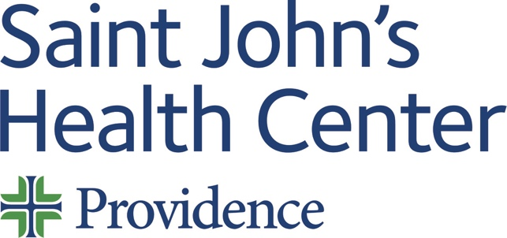

Live Activity:

Date: Wednesday 19 April 2023
Time: 10:00 AM

Target Audience: Physician, Physician Assistant, Nurse Practitioner, Pharmacist, Registered Nurse

Topic: “Emergency Medicine Monthly Conference”

Describe this activity (CME Programs are designed in a multidisciplinary fashion hence curriculum may differ slightly from Expert Speaker*)
This will be a monthly series of CME activities designed to meet the needs of ED physician and other ED staff.
How will this activity address cultural, linguistic & implicit bias gaps or disparities?
- Cultural & Linguistic Competencies addressed? Definition: “The ability and readiness of health care providers and organizations to humbly and respectfully demonstrate, effectively communicate, and tailor delivery of care to patients with diverse values, beliefs, identities and behaviors, in order to meet social, cultural and linguistic needs as they relate to patient health.”
- Implicit Bias addressed? Definition: “The attitudes, stereotypes and feelings, either positive or negative, that affect our understanding, actions and decisions without conscious knowledge or control. Implicit bias is a universal phenomenon. When negative, implicit bias often contributes to unequal treatment and disparities in diagnosis, treatment decisions, levels of care and health care outcomes of people based on race, ethnicity, gender identity, sexual orientation, age, disability and other characteristics.”
Professional Practice Gaps  Gaps are the difference between actual (what is) and ideal (what should be). List one or more problems in practice that this activity is attempting to address. | Educational Needs  Specify what the learner needs in order to close the gap. | Learning Objectives  What do you expect learners to be able to do as a result of this activity?  “At the conclusion of this activity, learners will be able to …”
1 Identify methods to reduce diagnostic, medication, and discharge-related errors in real time during clinical practice
2 Recognize and adopt different methods to efficiently navigate the triage process.
3 Recognize patterns of behaviors that can be associated with physician burnout in their own lives or in fellow physicians.
Sources:
Type of Needs:
The American Medical Association Physician’s Recognition Award and Continuing Medical Education Credit System
Saint John’s Health Center (SJHC) is accredited by the California Medical Association (CMA) to provide continuing medical education for physicians.

SJHC designates this live activity for a maximum of one (1.00) AMA PRA Category 1 Credit(s)™. Physicians should claim only credit commensurate with the extent of their participation in the activity.

This credit may also be applied to the CMA Certification in Continuing Medical Education.

Name of individual | Individual's role in activity | Name of Ineligible Company(s) / Nature of Relationship(s)
Judy Hyle, CHCP | CME Compliance Officer | Nothing to disclose - 03/10/2023
Marissa Zobrist, MD | Course Director | Nothing to disclose - 04/07/2023
David M Cutler, MD | Other Planning Committee Member | Nothing to disclose - 09/07/2022

For questions or concerns email: MedicalStaffServices2@providence.org
This email does not accept incoming messages.

