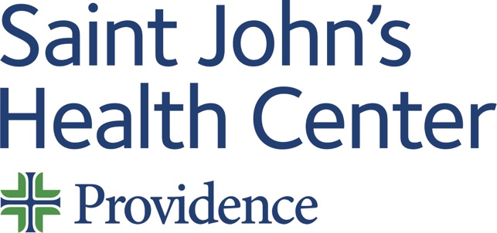

Date: Thursday 02 January 2025
Time: 08:00 AM

Target Audience: Colon And Rectal Surgery, Emergency Medicine, Family Medicine, Medical Genetics And Genomics, Obstetrics And Gynecology, Pathology, Radiology, Surgery, Thoracic Surgery, Internal Medicine-Critical Care Medicine, Clinical Biochemical Genetics, Clinical Genetics And Genomics (Md), Laboratory Genetics And Genomics, Medical Biochemical Genetics, Molecular Genetic Pathology, Gynecologic Oncology, Pathology-Clinical, Pathology-Molecular Genetic, Gastroenterology, General Surgery, Surgical Oncology, Diagnostic Radiology, Interventional Radiology And Diagnostic Radiology, Radiation Oncology, Nuclear Medicine, Pain Medicine, General Surgery, Complex General Surgical Oncology, Thoracic And Cardiac Surgery

Topic: “2025 GI Tumor Board”

Describe this activity
Text the code 3360 to the CloudCME phone number (844) 626-1442 to record your attendance during the meeting. | The multidisciplinary tumor board for review of evaluation, diagnosis, treatment, and follow-up of gastrointestinal cancer patients. Discussion to include radiology and pathology results, staging and treatment plans following national guidelines. This CME activity is for Medical Staff Members and APP's at Providence Saint John's Health Center.
Join Zoom Meeting
https://us06web.zoom.us/j/85398530268?pwd=enUwNFlHTkdUa2ROaWFvODZwT2xnUT09
Meeting ID: 853 9853 0268
Passcode: 132253

Learning Outcomes
1 Apply current research and guidelines appropriately when diagnosing, staging, and treating patients.
2 Implement strategies to improve patient satisfaction.
3 Increase learner confidence in their expertise and decision-making related to GI cancer.
CME Credit
Providence Saint John’s Health Center is accredited by the California Medical Association (CMA) to provide continuing medical education for physicians.

Providence Saint John’s Health Center designates this Live Activity for a maximum of 1.00 AMA PRA Category 1 Credit™. Physicians should claim only the credit commensurate with the extent of their participation in the activity.

Commercial and/or Exhibit Support
No commercial support has influenced the planning, implementation, or evaluation of the content of this activity.

Disclosure Information
Providence Saint John's Health Center Continuing Medical Education adheres to the ACCME’s Standards for Integrity and Independence in Accredited Continuing Education. Any individuals in a position to control the content of a CE activity, including faculty, planners, reviewers, or others are required to disclose all financial relationships with ineligible entities (commercial interests). All relevant financial relationships have been mitigated prior to the commencement of the activity.
Name of individual | Individual's role in activity | Nature of Relationship(s) / Name of Ineligible Company(s)
David M Cutler, MD | Planning Committee Member | Consulting Fee-Pfizer (Any division) (Relationship has ended) - 01/25/2024
Anton J. Bilchik, MD | Course Director
Trevan Fischer, MD, FACS | Course Director | Nothing to disclose - 06/29/2024
Judy Hyle, CHCP | CME Compliance Officer | Nothing to disclose - 11/07/2024

For questions or concerns email: MedicalStaffServices2@providence.org

